Laptops Packing for Air Freight
Laptops / Notebooks containing lithium batteries need to be packed as per IATA guidelines for air shipping. Please follow below instructions for laptops packing;
Laptops must be packed as per IATA guidelines as the shipment will be handed over for a passenger Airline. IATA guideline states that-
- Carton can have only 5 kg total weight of Lithium ION batteries, meaning if weight for each battery is estimated 0.5 kgs, then 10 laptops with the batteries can be packed in carton (recommended max 10 laptops in a box)
- Each laptop must be separated inside the carton with a cardboard wall or individual wrapping for product safety
- No Loose batteries to be kept in the box
- Each box must contain a Lithium ION battery label
- Maximum pallet height to be 63” (ground to the highest point)
- Outside on Pallet another Lithium ION label and an OVERPACK label to pasted
- Pallet to have a clear shrink wrap or black, and also proper strapping
We will appreciate if you can share pics and your process in place to ensure we are not asked to repack to meet IATA guidelines. Repacking is not just expense related but also causes delay. We appreciate your support.
Recommended Material/Boxes for Packing
Boxes
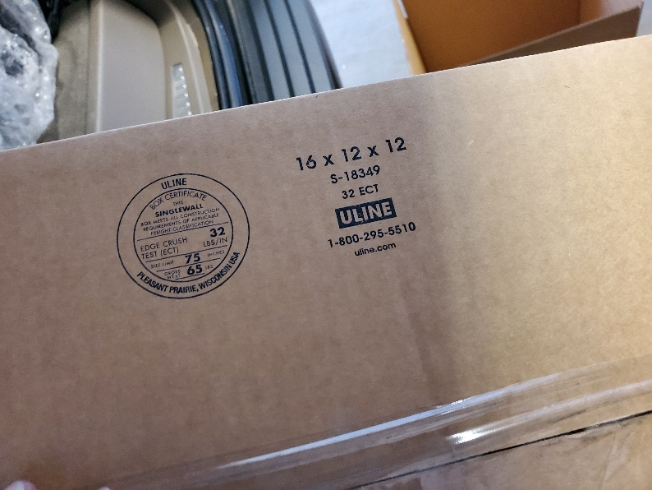

Cardboard / Dividers
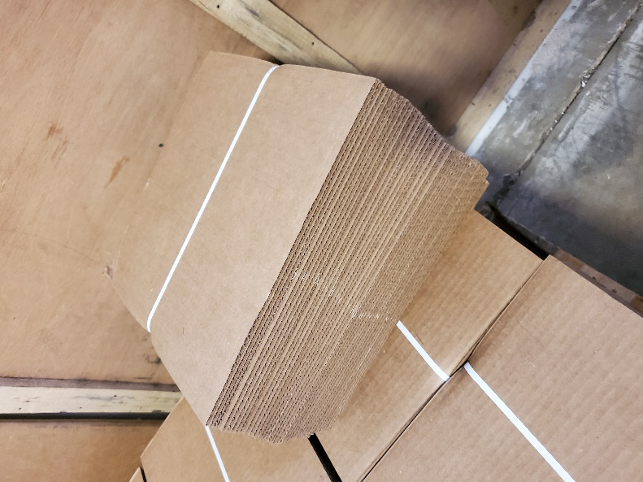 | 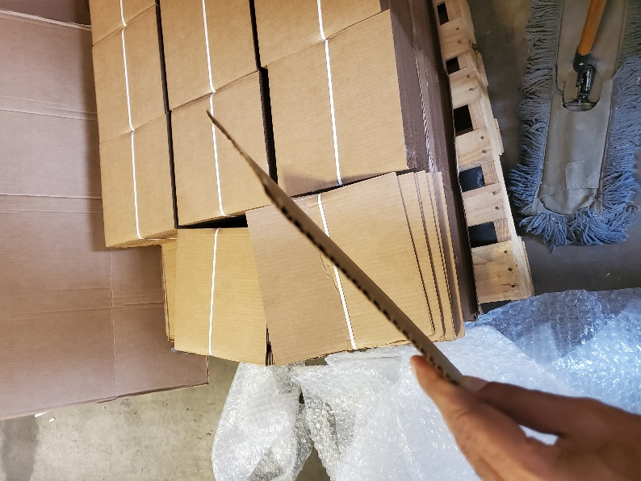
Packing
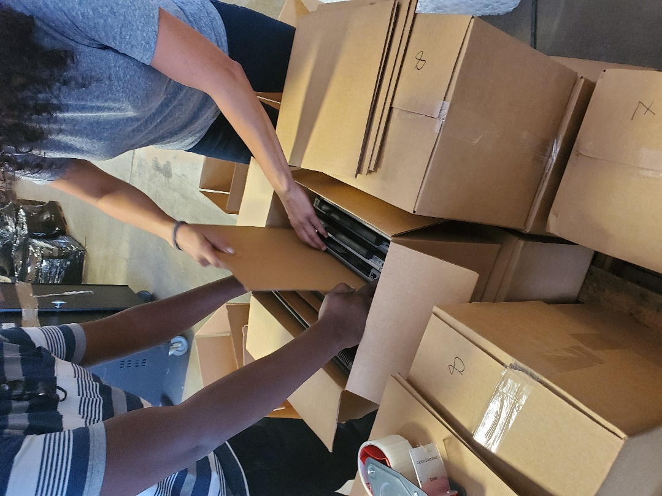

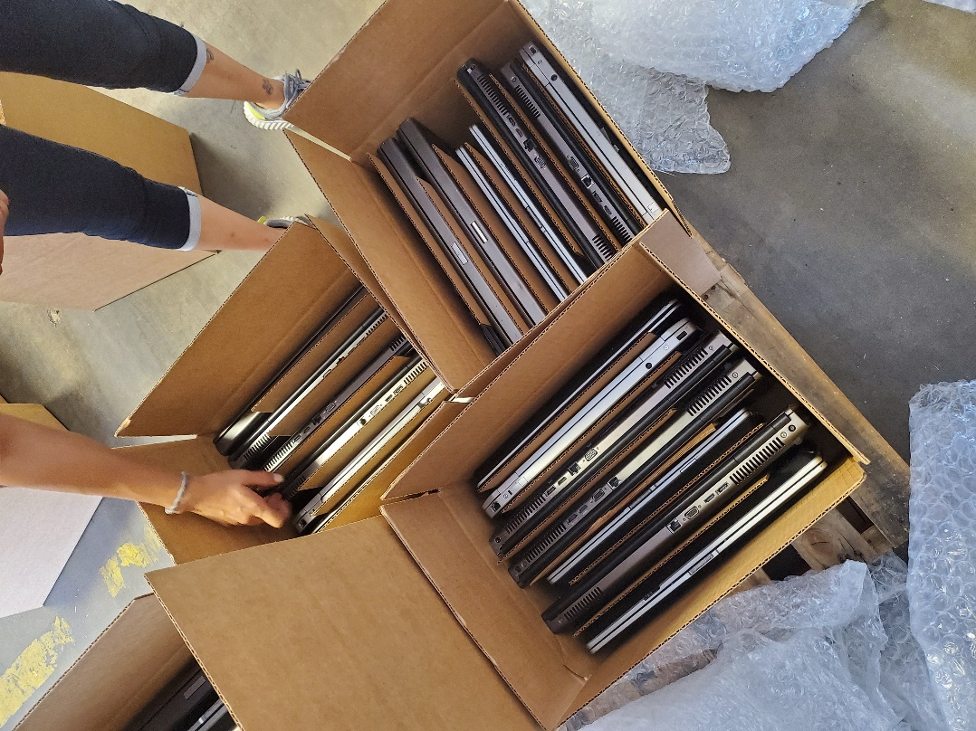

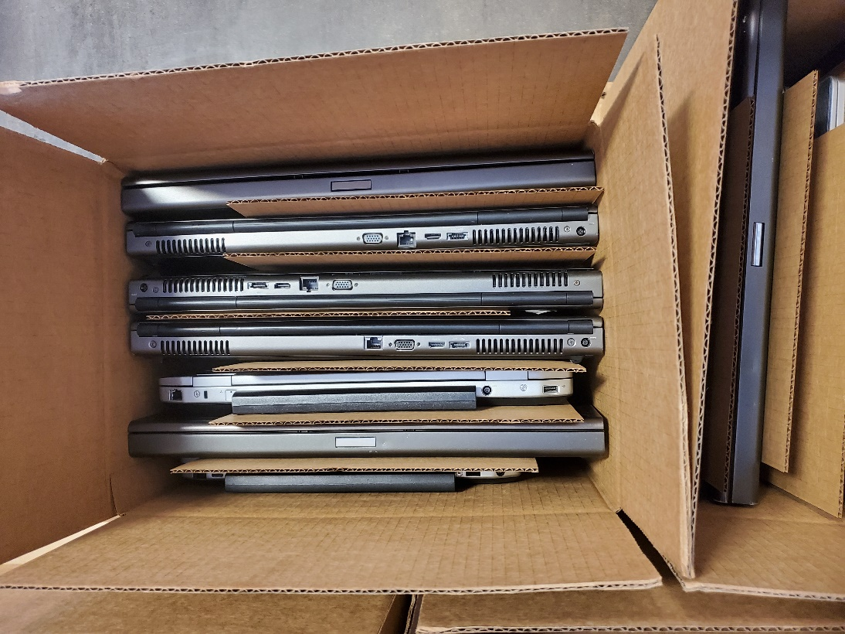

Pallet Height

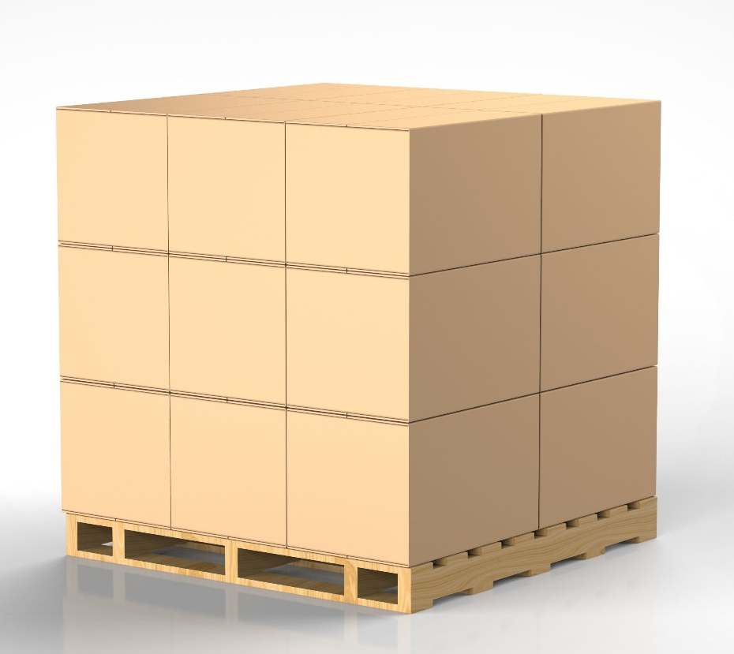
63 inches max

Pallet Wrapping



